Activity

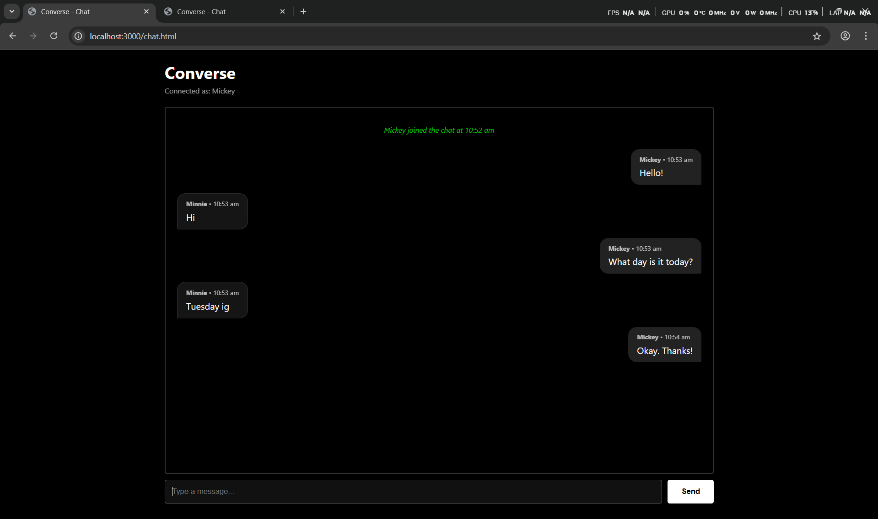

index.html
<!DOCTYPE html>
<html lang="en">
<head>
<meta charset="UTF-8">
<meta name="viewport" content="width=device-width, initial-scale=1.0">
<title>Converse - Join Chat</title>
<link rel="stylesheet" href="style.css">
</head>
<body>
<div class="login-container">
<div class="login-box">
<h2>Converse</h2>
<p>Pick a User ID to start chatting</p>
<form id="login-form">
<input type="text" id="userId" placeholder="Enter User ID..." required autofocus autocomplete="off">
<button type="submit">Join Chat</button>
<div id="error-message" class="error"></div>
</form>
</div>
</div>

<script src="/socket.io/socket.io.js"></script>
<script>
const socket = io();
const loginForm = document.getElementById('login-form');
const userIdInput = document.getElementById('userId');
const errorMessage = document.getElementById('error-message');

loginForm.addEventListener('submit', (e) => {
e.preventDefault();
const userId = userIdInput.value.trim();
if (userId) {
socket.emit('join', userId);
}
});

socket.on('join-success', (userId) => {
sessionStorage.setItem('converse_userId', userId);
window.location.href = 'chat.html';
});

socket.on('error-msg', (msg) => {
errorMessage.textContent = msg;
});
</script>
</body>
</html>

Chat.html
--
<!DOCTYPE html>
<html lang="en">
<head>
<meta charset="UTF-8">
<meta name="viewport" content="width=device-width, initial-scale=1.0">
<title>Converse - Chat</title>
<link rel="stylesheet" href="style.css">
</head>
<body>
<div class="container" id="chat-page">
<header>
<h1>Converse</h1>
<div id="status-bar" style="font-size: 0.8rem; opacity: 0.6; margin-top: 5px;">
Connected as: <span id="current-user-display">--</span>
</div>
</header>

<section id="chat-main">
<div id="message-display">
<!-- Messages will appear here -->
</div>

<form class="input-section" id="message-form">
<input type="text" id="message-input" placeholder="Type a message..." required autocomplete="off">
<button type="submit" id="send-btn">Send</button>
</form>
</section>
</div>

<script src="/socket.io/socket.io.js"></script>
<script src="chat.js"></script>
</body>
</html>

chat.js
--
const socket = io();

// Get UI elements
const messageForm = document.getElementById('message-form');
const messageInput = document.getElementById('message-input');
const messageDisplay = document.getElementById('message-display');
const currentUserDisplay = document.getElementById('current-user-display');

// Identification
const userId = sessionStorage.getItem('converse_userId');

if (!userId) {
window.location.href = 'index.html';
} else {
currentUserDisplay.textContent = userId;
// Tell the server who we are (in case of page refresh)
socket.emit('join', userId);
}

// Handle errors (e.g. duplicate during rejoin)
socket.on('error-msg', (msg) => {
alert(msg);
window.location.href = 'index.html';
});

// Handle sending messages
messageForm.addEventListener('submit', (e) => {
e.preventDefault();
const text = messageInput.value.trim();
if (text) {
socket.emit('chat-message', text);
messageInput.value = '';
messageInput.focus();
}
});

// Receive chat messages
socket.on('chat-message', (data) => {
const isSelf = data.userId === userId;
addMessageToUI(data, isSelf ? 'self' : 'other');
});

// UI helper to add messages
function addMessageToUI(data, type) {
const messageDiv = document.createElement('div');
messageDiv.classList.add('message', type);

const infoDiv = document.createElement('div');
infoDiv.classList.add('info');
infoDiv.innerHTML = `<strong>${data.userId}</strong> &bull; ${data.timestamp}`;

const textDiv = document.createElement('div');
textDiv.textContent = data.text;

messageDiv.appendChild(infoDiv);
messageDiv.appendChild(textDiv);
messageDisplay.appendChild(messageDiv);

// Auto-scroll
messageDisplay.scrollTop = messageDisplay.scrollHeight;
}

// Receive system events
socket.on('user-event', (data) => {
const systemDiv = document.createElement('div');
systemDiv.classList.add('message', 'system');

let text = '';
if (data.type === 'join') {
text = `${data.userId} joined the chat`;
} else if (data.type === 'leave') {
text = `${data.userId} left the chat`;
}

systemDiv.textContent = `${text} at ${data.timestamp}`;
messageDisplay.appendChild(systemDiv);

// Auto-scroll
messageDisplay.scrollTop = messageDisplay.scrollHeight;
});

style.css
--
:root {
--bg-color: #000000;
--text-color: #ffffff;
--border-color: #333333;
--input-bg: #111111;
--accent-color: #00ff00;
}

* {
box-sizing: border-box;
}

body, html {
margin: 0;
padding: 0;
height: 100%;
font-family: 'Segoe UI', Tahoma, Geneva, Verdana, sans-serif;
background-color: var(--bg-color);
color: var(--text-color);
}

.container {
max-width: 1000px;
margin: 0 auto;
height: 100%;
display: flex;
flex-direction: column;
}

header {
padding: 20px;
}

header h1 {
margin: 0;
font-size: 1.8rem;
}

/* Chatting Area with Border */
#chat-main {
flex: 1;
display: flex;
flex-direction: column;
padding: 0 20px 20px 20px;
overflow: hidden;
}

#message-display {
flex: 1;
border: 2px solid var(--border-color);
border-radius: 4px;
padding: 20px;
overflow-y: auto;
display: flex;
flex-direction: column;
gap: 15px;
}

/* Message Styles */
.message {
max-width: 75%;
padding: 10px 15px;
border-radius: 15px;
line-height: 1.4;
word-wrap: break-word;
}

.message .info {
font-size: 0.7rem;
opacity: 0.7;
margin-bottom: 4px;
}

/* User messages on right */
.message.self {
align-self: flex-end;
background-color: #222222;
border-bottom-right-radius: 2px;
}

/* Others on left */
.message.other {
align-self: flex-start;
background-color: #151515;
border: 1px solid var(--border-color);
border-bottom-left-radius: 2px;
}

.system {
align-self: center;
background-color: transparent;
color: var(--accent-color);
font-size: 0.8rem;
font-style: italic;
opacity: 0.8;
}

/* Input Section */
.input-section {
padding: 10px 0;
display: flex;
gap: 10px;
}

input[type="text"] {
flex: 1;
padding: 12px;
background-color: var(--input-bg);
border: 1px solid var(--border-color);
color: var(--text-color);
border-radius: 4px;
outline: none;
}

input[type="text"]:focus {
border-color: #666666;
}

button {
padding: 12px 24px;
background-color: #ffffff;
color: #000000;
border: none;
border-radius: 4px;
font-weight: bold;
cursor: pointer;
}

button:hover {
background-color: #eeeeee;
}

/* Login Screen */
.login-container {
display: flex;
flex-direction: column;
align-items: center;
justify-content: center;
height: 100vh;
}

.login-box {
border: 1px solid var(--border-color);
padding: 40px;
border-radius: 8px;
text-align: center;
width: 100%;
max-width: 400px;
}

.login-box h2 {
margin-top: 0;
margin-bottom: 20px;
}

.login-box input {
width: 100%;
margin-bottom: 15px;
}

.login-box button {
width: 100%;
}

.error {
color: #ff4d4d;
margin-top: 10px;
font-size: 0.9rem;
}

